**DEVELOPMENT OF APPOINTMENT SCHEDULING APPLICATION FOR DIALYSIS PATIENTS**

A CAPSTONE PROJECT

Presented to the Faculty of the

College of Information Technology

Tagoloan Community College

Tagoloan, Misamis Oriental

In Partial Fulfilment

of the Requirements for the Degree

Bachelor of Science in Information Technology

By

MC RAVEN ROA

AIZIEL V. CABANES

DANIEL B. LEGUMBRES

MARK WILLIAM B. SABUNOD

FRANCASIO B. ZAMAYLA ll

LEONARD JUN P. PIL

SEPTEMBER 2025

Chapter 4

Result and Discussion

The information was gathered and the data analysis is presented in this chapter. This chapter outlines the findings and outcomes of the designed Appointment Scheduling Application for Dialysis Patients. This project was mainly focused on overcoming the inability of the manual scheduling process by implementing an automated application that schedules dialysis sessions, reduces schedule conflicts, and enhances communication among patients, medical practitioners, and administrative personnel. Precisely, the application was created to offer a friendly interface, automate booking appointments, send timely reminders, and provide safe patient information management. In this chapter, emphasis is laid on how these goals were met by highlighting the real functionality, usability, and performance of the application in action. It emphasizes how the implemented solution ensures operational efficiency, improves patient satisfaction by way of accurate reminders and scheduling, and lessens healthcare staff workload through automated common tasks. In addition, this chapter assesses the system's overall performance to ensure that it addresses the project's desired goals of efficiency, reliability, and user satisfaction while exhibiting its potential as a model in comparable healthcare facilities. The presentation of discussions and results in this chapter is structured following the stages of the selected methodology so that there can be a clear and systematic explanation of system development from requirements analysis to design, testing, implementation, and deployment.

Requirements Analysis (Phase 1)

In this phase data gathering and requirements analysis for the development of Appointment Scheduling Application for Dialysis Patients. The process entailed exploring the practices being followed at the dialysis center, which were primarily manual scheduling with the use of whiteboards, printed checklists, and spreadsheets. These conventional techniques proved to be hard to handle , prone to errors, and hard to handle to administer with a large number of patients, usually leading to double bookings, scheduling problems, and delayed alerts. To accurately determine the scope and functions of the system, an interview was held with the head nurse through an open-ended questionnaire, and the conversation was recorded for thorough analysis. This exercise generated useful information on the day-to-day working routine of the staff, the shortcomings of the existing methodology, and the distinct demands of patients who need uniform, regular treatments. Based on these results, the critical system requirements were enumerated, such as secure user authentication, effective booking and rescheduling of appointments, conflict detection, role-based access for patients and staff, and automated notification capabilities. The deliverable of this stage was an extensive Software Requirements Specification (SRS) document, which became the basis of system design and influenced the following development stages.

System Design (Phase 2)

In this phase took the requirements that were obtained and translated them into an in depth application design that would act as the development blueprint. This stage involved developing the technical framework and user interface that would solve the scheduling issues highlighted in the requirements analysis. Various design tools were employed in this phase to make sure there was clarity and accuracy in the system representation. Figma was utilized to create wireframes for the staff and patient appointment calendar and scheduling screens, giving a clear picture of the patient and staff user interface. Lucidchart was utilized to build an Entity Relationship Diagram (ERD), illustrating the logical database structure and highlighting how patient records, appointments, and staff schedules would be related to one another. Besides, Draw.io was utilized to show the application architecture, highlighting the interactions between various modules like authentication, appointment booking, notification services, and data storage. This process of design ensured that all required features like slot availability check, conflict detection, reminder of notifications, and role-based access were translated into a unified framework.Deliverable in this phase were user interface prototypes, a comprehensive ERD, and a application architecture document, which taken directed the development process in the following implementation stage.

This Entity–Relationship Diagram (ERD) maps a Appoinment Scheduling Application for Dialysis Patient to bind patients, nurses, admins, notifications, and dialysis machines all into one systematic flow. The admin registers patients into the system by entering their personal details including name, email, and login credentials. After registering, patients are able to schedule appointments for the dialysis sessions, which are logged in the system against details like date, time status, nurse assigned, and dialysis machine. Each appointment is seen by a nurse, who is determined by shift schedule and contact information, so medical aid is available during the session. The dialysis machine is a valued resource, distinguished by machine type, status, and location, and is designated to patients at their respective appointment times to guarantee suitable equipment utilization. To inform patients, the system produces notices, which are sent to remind or update them concerning their appointments and associated details. In summary, this diagram shows how the system harmonizes roles, processes, and resources to effectively manage dialysis treatments so that timely care is provided to patients while nurses and admins are able to monitor and coordinate schedules easily.

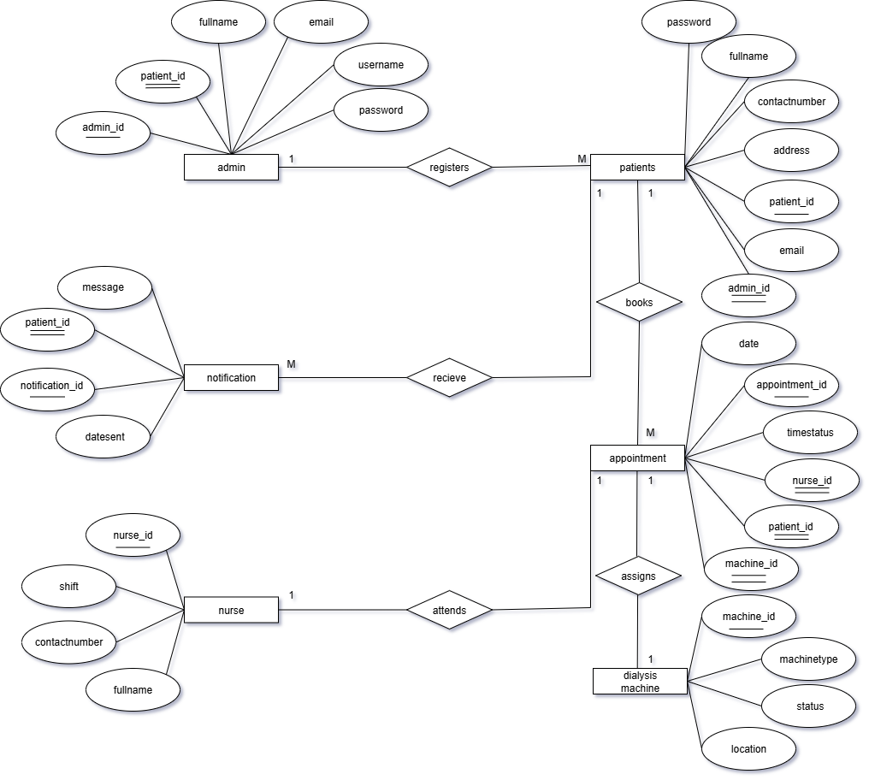

Figure 3.0 Entity Relationship Diagram

The Data Flow Diagram (DFD) of the Appoinment Scheduling Application for Dialysis Patient illustrates the interaction between the system and its main actors which is the Admin, Nurse, Patient, and the Notification service. Patients can register or log in, submit appointment requests, and request cancellations or rescheduling. The system then provides appointment confirmations, details, reminders, notifications, and status updates back to the patients. Admins have full control of the system, including approving or rejecting appointment requests, managing patient records, managing nurse accounts, and generating reports. They also oversee record management and reporting functions. Nurses, on the other hand, receive daily appointment schedules, patient information, system notifications, and summary reports from the application. They can also view assigned appointments, update patient statuses, acknowledge notifications, and send feedback or notes. Additionally, the Notification service delivers reminders and important updates to patients, ensuring they are informed of their schedules. Overall, the DFD shows how the Appointment Scheduling Application streamlines coordination between patients, nurses, and administrators while maintaining efficient record management and timely communication.

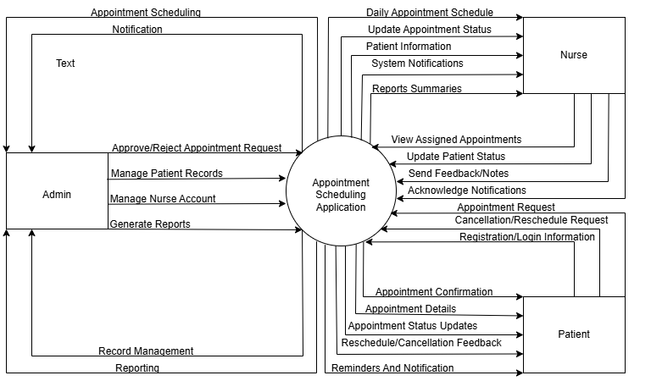

Figure 4.0 Data Flow Diagram

The use case diagram shows how the Appoinment Scheduling Application for Dialysis Patient facilitates the core users admin, patients, and nurses to perform their individual tasks. The admin has the duty of managing system processes like logging in, user account management, patient registration, report generation, and logging out. Such operations also cover patient management and appointment and patient data handling to make sure the records are accurate and current. Conversely, the patients engage with the system through scheduling appointments, viewing appointment information, and receiving schedule notifications. They are also able to cancel appointments if needed, providing them with convenience in scheduling their treatment sessions. Nurses, on the other hand, are critical in appointments by taking down patients' vitals, allocating dialysis machines, and changing the status of every appointment. Taking vitals is extended to accompanying the appointments, so patients can be given proper monitoring during treatment. The diagram further illustrates included functions, which are required system tasks, and extended functions, which are conditional or optional tasks. Generally, the system is aimed at balancing the jobs of admins, patients, and nurses, thus simplifying the process of scheduling, handling, and visiting dialysis sessions to be more efficient and reliable.

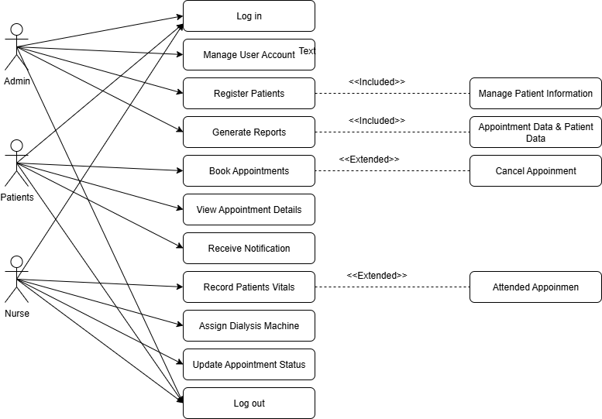

Figure 5.0 Use Case Diagram

Implementation (Phase 3)

In this phase was the actual implementation of the Appoinment Scheduling Application for Dialysis Patient according to the results of the design phase. With Flutter being the main framework, the proponents created a cross-platform mobile app that can be used on both Android and iOS platforms. Firebase was used as the backend service to manage real-time data storage, user authentication, and push notifications so that appointment records and communications were securely and efficiently handled. The deployment process was modular, starting with the creation of the core features including appointment booking and rescheduling, checking for slot availability, and preventing conflicts. Role-based access control was also enforced, where patients, administrators, and staff could interact with the system based on their assigned privileges. Notification reminder, another important module built, sent reminders of pending appointments automatically, reducing missed sessions and ensuring higher patient compliance. Version control was done using GitHub, facilitating systematic tracking of code change and collaborative development by the team. The outcome of this stage was a working beta version of the app that illustrated the fundamental appointment management features, awaiting more refinement and tests in the testing phase.

Testing and Evaluation (Phase 4)

In this phase is focusing on validating that the Appointment Scheduling Application for Dialysis Patient, which was developed, operated as per the requirements laid down in the previous stages. Testing procedures were performed to verify the accuracy, reliability, and usability of the system with special focus on its scheduling and notification aspects. To mimic back-end operations within a secure environment, Firebase Emulator was used, while Android Debug Bridge (ADB) permitted the app to be tested across various mobile devices for performance and compatibility. Functionality testing was executed to ensure booking, rescheduling, and slot conflict checking for checking double-bookings as well as errors to confirm that these were prevented effectively. The user interface responsiveness was also evaluated to ensure that patients and staff were able to use the system without any hindrances. Further, User Acceptance Testing (UAT) was conducted with some pre-selected dialysis staff and patients, who provided suggestions on the ease of use of the system, features clarity, and performance overall. Their feedback was gathered using surveys and feedback forms, which helped determine areas of improvement. JIRA was utilized to manage bugs, issue monitoring, and feature requests for polishing. The outcome of this phase confirmed that the system was reliable, operating, and user-friendly, as it served its intended purposes and prepared the ground for eventual deployment.

Deployment (Phase 5)

In the last phase focused on the deployment of the Appoinment Scheduling Application for Dialysis Patient for actual use in the dialysis center. The application was ready for real-world implementation during this phase after the successful completion of testing and evaluation. Internal release of the application was first conducted by providing APK files to staff and some patients, enabling them to test the system in a controlled setting. To facilitate easy adoption, the advocates created user manuals and training resources that offered concise step-by-step instructions on how to work with the system's functionalities, such as scheduling appointments, viewing schedules, and managing notifications. There were also demonstrations and training exercises performed with the healthcare staff in creating familiarity and confidence in utilizing the application within their day-to-day work. This method reduced resistance to change and facilitated smooth transition from manual scheduling to automated scheduling. Deployment was also focused on user assistance and feedback gathering to determine possible adjustments for future releases. The system was successfully deployed as an operational tool for scheduling dialysis appointments by the end of this phase, representing the realization of the development phase and laying the groundwork for long-term usage, upkeep, and potential expansion to other hospitals.